Topic: Information Systems

# Lesson 1: Information System Basics

|  |  |
| --- | --- |
| Aim | 0b •ectives |
| Master communication skills and competences in information system basics and planning and analysis procedures within system development life cycle | At the end of this lesson, students will be able to:   * define the concept of the information system * describe information systems' goals, applications, and types * state the concept of SDLC and define its main phases • list core activities of the planning and analysis phases and their main goals * discuss and present findings in pairs and small groups * write a summ based on different media |

## I. Lead-in

l. Study the definitions of the terms "information " and "system " in relation to IT in the box and share your opinion on the ideas below.

|  |  |
| --- | --- |
| a) Computer-based information systems have spread | Information — news, |
| rapidly and are now an essential component of every business, organisation, and enterprise. | facts, or knowledge |
| b) Just about any type of enterprise can benefit from an | about a person, |
| information system, from a small start-up to an established multinational corporation. | company, product, |
| c) Not everyone in an organisation uses an information | System — computer |
| system in the same way. | equipment and |
| d) A wide variety of enterprise software can be included in information systems to help owners, managers, | programs used for a |
| and executives monitor all aspects of a business. | particular purpose |

2. Look at the picture illustrating the components of a computer-based information system. Work out your definition of an information system and present it to the group. Work in groups ofthree orfour people.

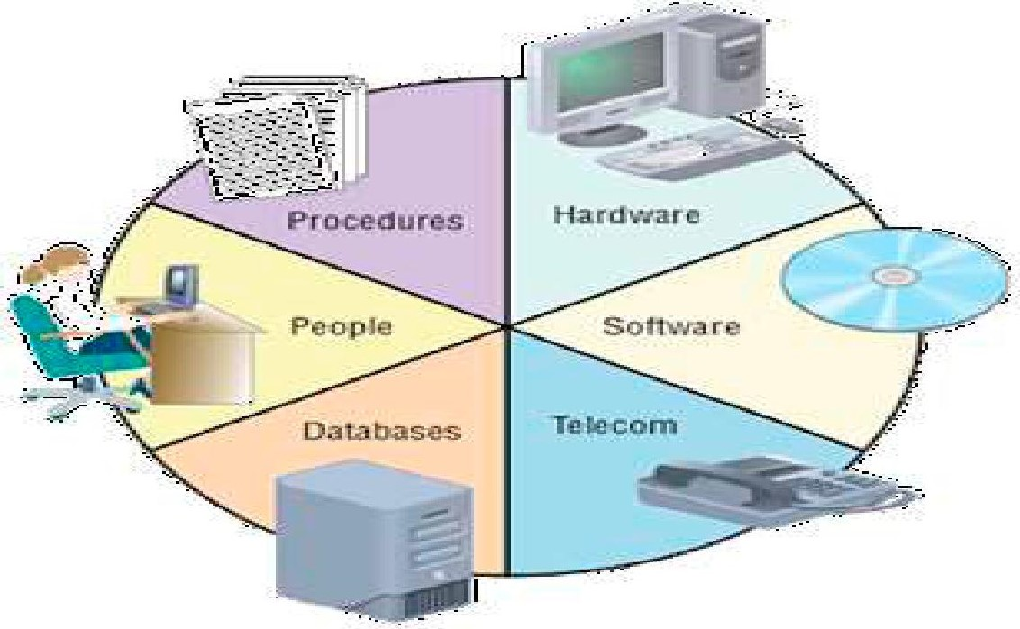

## Il. Vocabulary Focus

l. Study the definitions of an information system below. Work out the meaning of the words in bold. Then answer the following questions.

1. What do these definitions have in common?
2. How do they differ?
3. Which definition is the most comprehensive? Why?

l. An information system collects, stores, and processes data to provide useful, accurate, and timely information, typically within the context of an organisation.

1. An information system can be defined as a set of interrelated components that collect, process, store, retrieve, and distribute information to support decisionmaking, coordination, and control in an organisation.
2. An information system must support the needs of people who engage in many different organisational activities.
3. An information system can help people perform their jobs more quickly and effectively by automating routine tasks, such as reordering inventory, taking customer orders, or sending out renewal notices.
4. One of the major functions of an information system is to help people make decisions in response to problems.
5. Business firms and other organisations rely on information systems to carry out and manage their operations, interact with their customers and suppliers, and compete in the marketplace.
6. Nothing is more central to an organisation's effectiveness than its ability to transmit accurate, relevant, and understandable information amongst its employees.
7. Match the words in the box with the synonyms in bold in Task l.

participate in; connected; correct; extract; notifications; concerning; at the right time; items; appropriate; perform; try to beat other companies

1. Do the quiz to find out what you know on the topic of information systems. More than one option can be correct.

|  |  |
| --- | --- |
| l . Different information re uires to be . | a) searched c) sorted b cate orised d stored |
| 2. Why do people depend on information systems? | 1. they help us manage all massively stored data 2. they retrieve databases 3. they control information 4. they compete with end-users |
| 3. An information system is a set of | 1. computers for collecting, storing, and processing data 2. collected computers storing and processing data 3. computer-based tools for collecting, storing, and processing data d uninterrelated com onents workin to ether |
| 4. The main components of a typical information system are . | 1. hardware 2. software 3. networks d data |
| 5. Information systems are widely used by . | 1. government 2. business 3. health care d education |

1. There are the four major types of information systems. Match the types with the appropriate definitions (a e). One definition is extra.

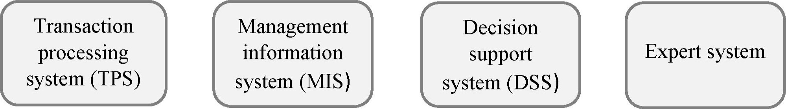

* 1. It helps people make decisions by directly manipulating and accessing data from external sources, generating statistical projections, and creating data models of various scenarios.
  2. It provides a way to collect, process, store, display, modify, or cancel transactions. Most of these systems allow many transactions to be entered simultaneously.
  3. It uses computer circuitry to simulate the way a brain might process information, learn, and remember. Based on the evidence, it begins to establish its own criteria, its own rules about the data.
  4. It's sometimes referred to as a "knowledge-based system"; it's a computer system designed to analyse data and produce a recommendation, diagnosis, or decision based on a set of facts and rules.
  5. It is used to derive various reports from transaction data. Managers depend on these reports to make routine business decisions in response to structured problems.

1. Complete the passage about an information system with the words and word collocations in the box.

clients; procedures; people; software; feature; database; information system; devices; data; support

The information system is made up of five fundamental components: hardware, 1) data, networks, and people. Hardware resources consist of all physical 2)  and materials used for input, output, and processing of data. Software resources not only include the programs to control and coordinate the hardware but also the 3) which are operating instructions for the people who will use an information system. The third component is 4) By itself, data is not really very useful. But aggregated, indexed, and organised together into a(n) 5) data can become a powerful tool for businesses. Technically, communications networks are made up of hardware and software, but they are such a core 6)  of today's information systems that they have become its own category. Network resources include communications media, networks and network 7) The final and probably the most essential component of an information system is 8) without whom the previous four components can not function. Human resources include two types of people — the end-users, also called users or 9) who use an information system or the information it produces, and the 10)  specialists like computer operators, analysts, programmers, etc. who develop and operate information systems.

1. Different types ofinformation can he stored on a blockchain. Watch the video "What Is the Blockchain? " [57] and choose the optionsfrom the ones given in italics to make correct sentences.
   1. A blockchain is a public/private ledger.
   2. Think of it as a full history of banking records/transactions.
   3. Bitcoin isn't regulated by a central audience/authority.
   4. The completed transaction is publicly recorded into the blockchain where it is verified/varied by other Bitcoin users.
   5. It can review transaction histories to determine how much volume/value a particular address owned at any time.
2. Watch the video again and complete the abstract with the missing words.

A blockchain is a public ledger that records all Bitcoin transactions 1)the need for a third party to process payments. Think of it as a full history of banking transactions. Blocks with the most recent transactions being recorded are like an individual banking 2) Each completed block is 3)  to the chain and another block begins forming the constantly growing blockchain. Bitcoin isn't regulated by a central authority. Instead, its users dictate and 4)  transactions when one person pays another for goods or services. The completed transaction is publicly recorded into the blockchain where it is verified by other Bitcoin users. Blockchain is seen as 5)  main technological innovation. Since it provides 6) of each transaction, it can review transaction histories to determine how much value a particular address owned at any time. Each computer that's connected to the Bitcoin network 7)  a copy of the blockchain upon joining the network. Blockchain info provides 8) to the entire Bitcoin blockchain.

1. Share your opinion on the questions. Work in groups of three orfour people.
   1. What is an information system? Who uses information systems?
   2. What are the essential components of an information system?
   3. Can you describe the characteristics of TPS, MIS, DSS, and expert systems?
   4. What is blockchain technology?
   5. Why is blockchain important?

## Ill. Language Box

l. Information systems can serve different kinds ofenterprises. Match the pictures with the core areas oflheir application. Can you add otherfields ofapplication?



1. 2. 3. 4. 5. 6. 7.



|  |  |
| --- | --- |
| Travel and Hospitality | v/ Manufacturing |
| •Z Local Government | v/ Education |
| v/ Communication v/ Retail | v/ Health Care |

1. Read about the core business activities the information systems can help various kinds ofenterprises monitor and improve their performance. Find the words and word combinations in the sentences (1—7) that are similar to the ones in the box. Decide which areas ofapplication in Task I the activities refer to.

checkouts; power cuts; manage; obeying a law; checklist; a ment; arran e; em 10 ees

* 1. Manage patient records, deal with insurance claims, and schedule appointments.
  2. Provide an online platform for customers to make reservations, schedule facilities and equipment, and schedule employees.
  3. Manage customer subscriptions and billing, track service area, contact customers with special offers, monitor the network for power outages and track service and repair crews.
  4. Automate the design process, schedule suppliers, track orders, manage inventory, sales, and shipments, and monitor safety.
  5. Operate point-of-sale systems in stores and online, process payments, and maintain inventory.
  6. Manage student records, maintain data on instructors and staff, handle course registration, and schedule courses and facilities.
  7. Manage local tax compliance, improve financial management and reporting, maintain property records, and store employee data.

1. Search the Internet to find the mission statement for three businesses or nonprofit organisations that you respect. Predict what information systems they can use. Report yourfindings to the group.
2. There is a particular process for creating an information system. Look at the diagram below and discuss the following questions. Work with a groupmate.
   1. What does SDLC stand for?
   2. How many phases does it consist of?
   3. Which phase comes first?
   4. What is the goal of every phase?
   5. What activities does each phase encompass?

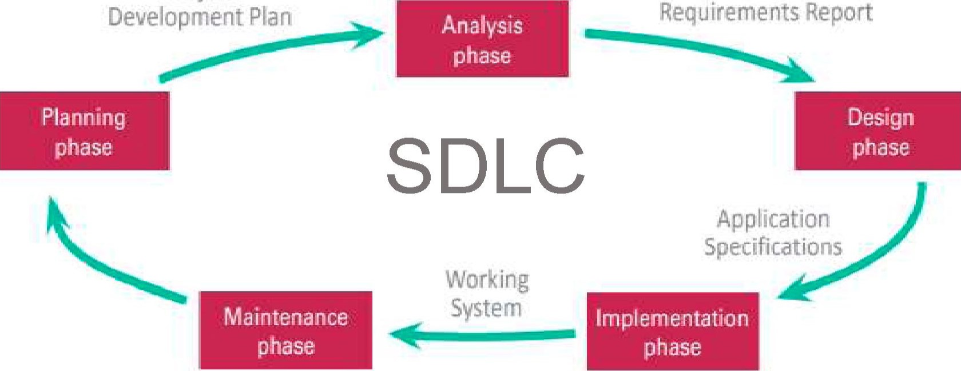

Project

System

1. Decide which of the following goals (a d) correspond to the main phases of the SDLC in Task 4. What phase is missing? Then watch the video "System Development Life Cycle " [46] and check your ideas.
   1. It is aimed at the building of a new software system according to the gathered requirements and design specifications.
   2. It refers to devising a detailed plan that includes a short description ofthe project, strategic scheduling, budget and resources required.
   3. It deals with studying system requirements and project goals.
   4. It refers to producing a plan for building the system and defining the architecture, interfaces and data structures.
2. Watch the video again and change the words in italics to make correct sentences.
   1. The SDLC has a set of four fundamental phases: planning, analysis, design and maintenance.
   2. Different projects might execute different parts ofthe SDLC or approach the SDLC phases in different ways, but all projects have elements of these four phases.
   3. In the SDLC, planning refers to the phase of creating a detailed plan for how the project will be launched including the scheduled budget and resources required.
   4. The analysis phase in the SDLC is the process of gathering and evaluating information about the goals of the system being developed to produce a clear understanding of the problem and requirements.
   5. In the SDLC design refers to the phase of creating a plan for building the system, including defining the requirements, interfaces, and data structures.
   6. Implementation in the SDLC refers to the phase of actually building and developing the software system according to the design resources created in the previous phases.
3. Choose the options from the ones given in italics to make correct sentences.

l . An information system is an essential optional component of every business, organisation, or enterprise.

* 1. An information system is a set of computer-based tools for collecting, storing, and scheduling processing data.
  2. An information system is essentially made up of five components: hardware, software, data queries, networks, and people.
  3. A standard SDLC begins proceeds with the planning phase and then it continues to analysis, design, implementation, and maintenance.
  4. The SDLC provides a general rigid outline of how an information system evolves.
  5. The phases in an SDLC are always not always separate steps.
  6. The SDLC is a formal multi-stage process through which information systems are implementedjustified.

1. Distribute the activities below between the following phases of the SDLC.



* 1. Identify potential solutions.
  2. Fix bugs.
  3. Obtain approval to implement the new system.
  4. Write a code using the chosen programming language.
  5. Assemble the project team.
  6. Create applications.
  7. Test the functionality of the entire system.
  8. Determine system requirements.
  9. Study the current system.
  10. Justify the project.

|  |  |
| --- | --- |
| k) Convert to the new system. | Methodologg — a system of |
| l) Evaluate solutions and select the best. | ways of doing, teaching, or |
| m) Choose a development methodology. | studying something |

* 1. Develop a project schedule.
  2. Upgrade the application to the newer versions of the software.
  3. Finalise documentation.
  4. Write a requirements report.
  5. Develop application specifications.
  6. Add some new features into the existing software.

1. Share your opinion on the questions with a groupmate.
   1. What is the SDLC and what is its main goal?
   2. What are the phases of it?
   3. What phase is the most time-consuming? Why?
   4. What phase would you like to be involved in? Why?

IV. Decision Bank

l. Read the abstract "SDLC: Planning Phase " and indicate the parts (A C) where the following ideas are mentioned.

l. The content of the project development plan.

1. Project team direction.
2. The objective of the planning phase.
3. Project rationale.
4. Planning phase tasks.

# SDLC: Planning Phase

A. The planning phase for an information system project includes the activities listed in the box on the right. The goal of these activities is to create a Project Development Plan. Before the project proceeds beyond the planning phase, the Project Development Plan is usually reviewed and approved by management. This planning document includes:

|  |  |
| --- | --- |
| - a short description of the project, including | Planning Phase Activities: |
| its scope; | v/ Assemble the project team |
| - a justification for the project, which includes | Justify the project |
| an estimate of the project costs and potential financial | '/ Choose a development |
| benefits;  - a list of project team participants; | methodology |
| - a schedule for the project, including an | v/ Develop a project schedule |
| outline of its phases. | v/ Produce a project |
| B. Depending on the scope of the problem and | development plan |

the expertise of the professional staff, an information systems project can be managed by an in-house information technology department or outsourced to a development firm. A system development project team, or project team for short, is assigned to analyse and develop an information system. The project team has a leader, sometimes referred to as the project manager, who supervises the project team's workflow and output.

C. Justifying a project often involves identifying problems and opportunities within an organisation's current information system. By eliminating problems and taking advantage of opportunities, an organisation can become more competitive. Project team members can identify problems and opportunities using a variety of techniques, such as interviews and data analysis.

1. Share your opinion on the ideas with a groupmate.
   1. Identify the goal of the planning phase.
   2. Name core activities that are completed during the planning phase.
   3. List the documents that a Project Development Plan includes.
   4. Explain what project justification means.
2. Read the abstract "SDLC: Analysis Phase " and consider the following key ideas.

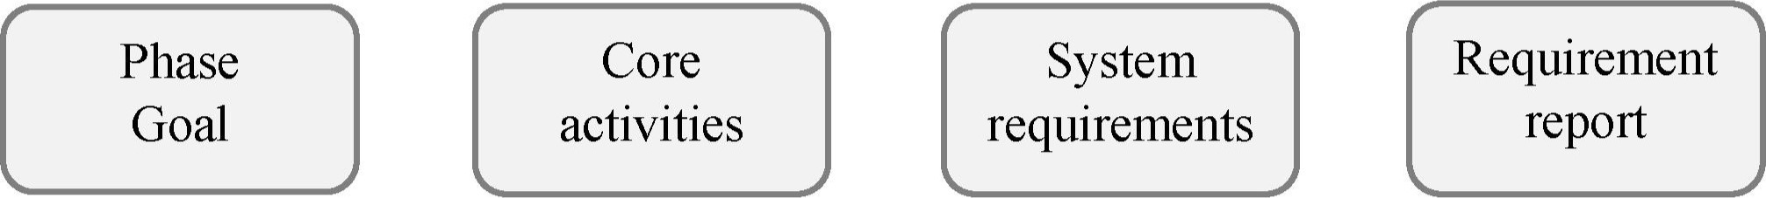

# SDLC: Analysis Phase

The goal of the analysis phase is to produce a list of requirements for a new or revised information system. Tasks for the analysis phase are listed in the box below.

Most new information systems are designed to replace a system or process that is Analysis Phase Activities: already in place. It is important to study the v/ Study the current system current system to understand its strengths and Determine system requirements weaknesses before designing a new system. v/ Write a requirements report Some members of the project team might have first-hand experience with the current system. They can often provide an overview of the system and identify key features, strengths, and weaknesses. To obtain additional information about the current system, project team members can observe the system in action and interview people who use it.

System requirements are the criteria for successfully solving problems identified in an information system. These requirements guide the design and implementation for a new or updated information system. They also serve as an evaluation checklist at the end of the development project; because of this, they are sometimes called success factors. A new or updated information system should always meet the requirements defined by the project team.

The project team determines requirements by interviewing users and studying successful information systems that solve problems similar to those in the current system. Another way to determine requirements is to construct a prototype as a trial version of an information system. Often the prototype is not a fully functioning system because it is designed to demonstrate only selected features that might be incorporated into a new information system. A systems analyst shows the prototype to users, who evaluate which features of the prototype are important for the new information system.

After the project team studies the current system and then determines what the new system should do, system requirements are incorporated into a document called a System Requirements Report that describes the objectives for an information system.

4. Look at the key ideas of this lesson and report on the topic "Information System Basics .

main components; information system types; SDLC; core activities; planning phase; financial benefits; problem identification; project scope; project development plan; trial version; prototype; project schedule; project justification; team participants; analysis phase; system requirements; success factors; selected features; revised s stem; re uirements re ort

## V. Conclusion Worksheet

Project plan Complete the assignment "Project Development Plan ' following the instructions below. Present it to the group. Work in groups oftwo or three people.

Identify and briefly describe an information system at university, work, or local business that needs improvement.

v/ Make a list of problems and opportunities that exist in that system.

v/ Develop a list of activities your team would perform, design, construct, and implement for a new information system.

v/ Incorporate all your findings into a document that would serve as the Project Development Plan.

## VI. Web Search

Explore the resources in the list to obtain additional information on information systems. Report yourfindings to the group.



https://www.britannica.com/topic/ https://vHHv.techopedia.com/definition/ https://www.investopedia.com/ information-system 24142/information-system-is terms/c/cloud-computing.asp

Ml. Revision Point

l. Read the abstract "How to Document System Requirements" and translate it into Belarusian or Russian. Use a dictionary ifnecessary.

# How to Document System Requirements

The System Requirements Report is one of the most important products of the SDLC. It documents key business practices in the current system and contains a list of success factors for a new or updated information system. If these factors have not been correctly identified, the information system will be a failure. The System Requirements Report must contain clear, complete, and detailed documentation, including diagrams and descriptions. The project team can use a variety of tools to diagram the current system and produce documentation that is also useful in later phases of the SDLC. Documentation tools vary depending on the development methodology. For example, a project team following a structured methodology will use different documentation tools than a project team using object-oriented methodology. To understand some of the most popular documentation tools, consider a project to develop an information system for a for-profit organisation that offers business seminars and workshops throughout the world. The new information system must keep track of workshop schedules and student enrolments. Students have to be able to select workshops, and instructors must be supplied with a roster of students.

1. Match the types ofinformation systems (1 6) with the appropriate descriptions (a—D.
   1. Online transaction processing system (OLTPS).
   2. Management information system (MIS).
   3. Decision support system (DSS).
   4. Executive information system (EIS).
   5. Expert system.
   6. Transaction processing system (TPS).
   7. It uses batch processing to collect and hold a group of transactions until the end of a day or pay period; generates detailed reports, which provide a basic record of the completed transaction.
   8. It uses a real-time method in which each transaction is processed as it is entered.
   9. It consolidates data collected by a transaction processing system by grouping and summarising it; provides more sophisticated reports to help analyse data.
   10. It makes decisions without direct guidance from an experienced decision-maker; uses a technique called fuzzy logic, it deals with imprecise data by working with confidence levels or with problems that have more than one solution.
   11. It helps people make decisions by directly manipulating data, analysing data from external sources, generating statistical projections, and creating data models of various scenarios, but the final choice remains the responsibility of the human decision-maker; it is not a substitute for human judgment.
   12. It is designed to provide senior managers with information relevant to strategic management activities based on information from internal and external databases.
2. Complete the gaps choosingfrom the options given to make correct sentences.
   1. The goal of the analysis phase is to  a list of requirements for a new or revised information system.
      1. produce b) revolve c) disrupt
   2. A new information system is designed to  a system or process that is already in place.
      1. restrict b) verify c) replace
   3. A new or updated information system shouldthe requirements the project team defines.
      1. exploit b) implement c) fulfil
3. The project team can use a variety ofto diagram the current system and specify what it does.

a) tools b) media c) metrics

1. A System Requirements Report describes thefor a new information system.



a) breaches b) objectives c) methodology

1. System requirements are the criteria for successfullythe problems identified in an information system.

a) solving b) satisfying c) retrieving

4. Get ready to speak on the topics below and assess your performance according to the following scale.

|  |  |  |
| --- | --- | --- |
| Comprehensive | Rather confident | Limited |

* Definition of an information system, its goals, and examples of applications.
* Types of information systems and their main characteristics.
* Blockchain technology.
* SDLC and its core phases.
* Planning phase, its goal, and main activities.  Analysis phase, its goal, and main activities.

# Lesson 2: System Design and Implementation

|  |  |
| --- | --- |
| Aim | 0b •ectives |
| Master communication skills and competences in the design and implementation phases within system development life cycle | At the end of this lesson, students will be able to:   * define the goals of the design and implementation phases • explain the technical criteria of software/hardware in the design phase * state software and hardware alternatives in the design phase * list types of testing and system conversion * present and discuss findings in pairs and small groups * write a summ based on different media |

## I. Lead-in

l. Complete the diagram with the activities of the design and implementation phases of the SDLC. Address Lesson I ifnecessary. Work with a groupmate.

|  |  |  |  |  |
| --- | --- | --- | --- | --- |
|  | | | |  | | --- | | Maintenance Phase | |
| Design Phase | |  | Implementation Phase | |

2. Share your opinion on the quotes. Justify your point ofview.

1. "The design process is about designing and prototyping and making. When you separate those, I think the final result suffers. " (Jonathan Ove)
2. "The designer does not begin with some preconceived idea. Rather, the idea is the result of careful study and observation, and the design is a product of that idea. " (Paul Rand)
3. "When I'm working on a problem, I never think about beauty, but when I've finished, if the solution isn't beautiful, I know it's wrong." (R. Buckminster Fuller)

## Il. Vocabulary Focus

l. Match the key terms related to the design and implementation phases of system development on the left with the appropriate definitions.

|  |  |
| --- | --- |
| 1. Implementation 2. Requirements 3. Manual 4. Creep 5. Turnkey 6. Specification 7. Conversion 8. Request 9. In-house | 1. complete product or service that is ready for immediate use. 2. the process of putting a decision or plan into effect; execution. 3. from one place to the next without stopping or changing; direct. 4. something that's mandatory or necessary. 5. an act of asking politely or formally for something. 6. a book giving instructions or information. 7. an act of identifying something precisely or of stating a precise requirement. 8. done or existing within an organisation. 9. the increase of something in a way that was not expected or wanted. 10. the process of deactivating an old information system and activatin a new one |

2. A myriad of hardware options are available for information systems. The project team has to consider the overall architecture based on device requirements, network technology, cloud hosting, and level of automation. Match the four options with the appropriate descriptions (A—D).

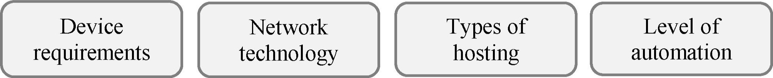

1. Virtually every information system requires a network, so the project team must examine different alternatives, such as LANs, extranets, Intranets and the Internet. Many information systems require a complex mixture of networks, such as a LAN in each branch office connected to a company Intranet, with customers accessing selected data via the Internet
2. The availability of these services offers yet another hardware option that can be addressed during the design phase. Rather than install an information system on costly in-house equipment, a viable alternative might be to install it in the cloud on equipment that is maintained by a cloud hosting company such as Amazon.com, Microsoft or Google
3. The project team should consider the pros and cons of different levels of automation because they affect all aspects of the planned information system. A point-of-sale system, a magnetic strip reader, a pressure-sensitive digitising pad, "tap-and-pay" systems, such as Apple Pay, are the examples
4. Servers and personal computers are the most commonly used components in information systems, but handheld devices, mainframes, and even supercomputers can also play a role. Systems analysts have to consider if users are accessing the system at the office or in the field. How much mobility is required? How much processing power and storage are required? Will screen size be an issue? These are some of the hardware questions that will be answered in the design phase

3. Software solutions can be explained through the cake analogy. Look at the pictures (1—4) and guess which ofthe following software alternatives they correspond to. Then read the cake preparation methods (a-d) below and match them with the pictures.

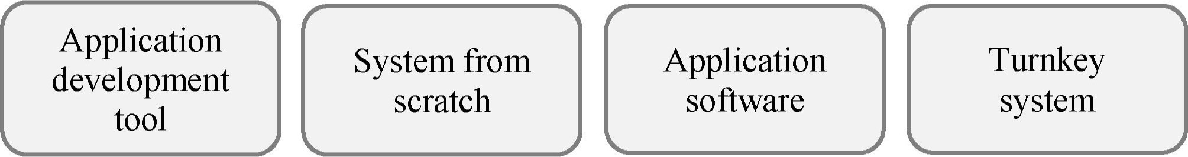

1. 2. 3. 4.



1. It is the so called "cake mix," which contains many of the ingredients necessary for quick and easy baking.
2. It is equivalent to buying a pre-made cake that you simply slice and serve.
3. Baking a cake allows you some flexibility in the ingredients you choosemargarine instead of shortening, for example. It requires a lot of time and work to sift the flour; mix the sugar, eggs, shortening, and milk.
4. It is like going out to dinner and simply ordering your choice of cake for dessert.
5. Read the characteristics ofsoftware solutions and define which type in Task 3 they refer to.
   1. It is costly, but you devise everything on your own and can choose how to do it.
   2. It contains system blocks that optimise the process of development.
   3. It saves your time, money, and resources.
   4. You can get constant updates from a software publisher in the future to meet system requirements better.
   5. It is significantly long.
   6. You can almost immediately start using this software.
   7. It needs evaluation to determine how well it meets the system requirements.
   8. It contains ingredients necessary for quick and easy development of the modules for an information system.
   9. It has some customisation options, but it cannot be modified to exactly meet every system requirement.
6. There might be more than one way to meet the requirements identified in the analysis phase of the SDLC. Complete the abstracts (A-D) below with the words in the box to learn more about the four potential software solutions.

turnkey; requirements; extensively; tool; satisfy; flexibility; kit; customisation; preprogrammed; adjustments; shells

* + 1. Creating an information system from scratch with programming tools using a programming language can take many months or years. It is usually costly but offers the most l) for meeting the system 2)
    2. An application development 3)  is essentially a type of software construction 4)containing building blocks that can be assembled into a software product. Expert system 5)  and database management systems are included. It usually speeds up the development process but might not offer the same level of flexibility as a programming language.
    3. Application software for an information system is usually a series of 6) software modules supplied by a software developer. It eliminates much of the design work required with programming languages or application development tools. Although most application software has some 7)  options, in many cases, it cannot be modified to exactly meet every system requirement, which necessitates 8) in an organisation's procedures.

system is essentially an "information system in a box," which consists of hardware and application software designed to offer a complete information system solution. It might seem like a quick and easy solution, and it looks attractive to many project teams. However, it must be 10) evaluated to determine whether it can 11) system requirements.

1. Make collocations with the words in the boxes. Make up some sentences with them in relation to the SDLC.

|  |  |  |  |  |  |
| --- | --- | --- | --- | --- | --- |
| A. programming customisation application | turnkey system scope | cloud user | B. manual system option | conversion software hosting | creep tool |

1. Find 15 words related to the design and implementation phases in the wordsearch below. Use the definitions. The first letter of each word is given in brackets. Copy the words into your notebook.
   1. The process of changing from one form to another (c).
   2. The process of putting a decision into execution (i).
   3. To make decisions about sth or to create potential solutions (d).
   4. Sth that you must do, or sth that is needed (r).
   5. Servers that are accessed over the Internet, and the software and databases that run on those servers (c).

|  |  |  |  |  |  |  |  |  |  |  |  |  |  |  |
| --- | --- | --- | --- | --- | --- | --- | --- | --- | --- | --- | --- | --- | --- | --- |
|  |  |  |  |  |  |  |  | s | 9 | 10 | 11 | 12 | 13 | 14 |
|  |  |  |  |  |  |  |  |  |  |  |  |  |  |  |
|  |  |  |  |  |  |  |  |  |  |  |  |  |  |  |
|  | b | m |  | a s |  |  |  |  |  |  |  |  |  |  |
|  |  |  |  |  |  |  |  |  |  |  |  |  |  |  |
|  |  |  |  |  |  |  |  |  |  |  |  | t |  |  |
|  | t | u |  | n |  |  |  |  |  | t | d | o |  |  |
| 7 |  |  | p | b | u | g | d |  |  | b | o |  |  |  |
|  |  |  | h | e | m | a | n | u |  |  |  | i |  |  |
| 9 | c | h | a |  |  |  |  | t |  |  |  |  |  |  |
| 10 | o |  |  |  | k |  |  |  |  |  |  |  |  |  |
| 11 | d | c |  |  |  |  | t |  |  |  |  |  |  |  |
| 12 | i |  |  |  | e | m | e |  | t | a |  |  |  |  |
| 13 |  |  | t |  |  | r | k | o |  |  |  | o |  |  |
| 14 |  |  |  |  |  |  |  |  | e |  |  |  |  |  |

* 1. A type of software testing that verifies a component of the system or the entire system under a realtime operating condition (p).
  2. A particular stage in a process or in the gradual development of sth (p).
  3. The excessive ongoing expansion or addition of new features in a product (c).
  4. A book giving instructions or information (m).
  5. The process of finding and fixing errors or bugs in the source code of any software (d).

I l . A testing technique performed to determine whether or not the software system has met the requirement specifications (a).

* 1. A sheet of information in the form of a table, graph, or diagram (c).
  2. Ready to be used immediately (t).
  3. The action of making or changing something according to the buyer's or user's needs (c).
  4. The processing of writing instructions for a computer (c).

## Ill. Language Box

l. Watch the video "Design Phase in SDLC" [32] and choose the options from the ones given in italics to make true statements.

1. A system is a combination of components that when combined create a finished initial product.
2. The design phase can be referred to as the transformation creation phase.
3. The design phase begins once the customer has planned signed offon the system. 4. Data is formed into charts files.
4. The book that explains how the system can be installed, its components and system requirements is known as the maintenance user manual.
5. The user manual explains how to fix bugs operate the new system.
6. At the end of this phase the design team should be sure that they met the resources requirements.
7. Watch the video again and match the beginnings of the statements (1—6) with the appropriate endings (a e).

|  |  |
| --- | --- |
| 1. The design phase can be referred to as the transformation phase 2. Data is formed into charts and the design team uses those charts 3. All of the components and security pieces of the system are 4. Along with the system there needs to be the book that explains. 5. Before the system can move on to the fourth phase 6. This allows assurance that the design team met | 1. the requirements and is on track to fulfilling the customer's needs. 2. the customer again needs to sign off. 3. also determined during the design phase. 4. because this is when an idea is actually transformed into a real working system. 5. how the system can be installed, its components, and system requirements. 6. to decide the best way for the data to move and be stored |

1. One oflhe activities in lhe implementation phase is testing. Identify which types of testing correspond to which descriptions. Then put them into the correct order.

|  |  |
| --- | --- |
| 1. System testing 2. Acceptance testing 3. Unit testing 4. Integration testing 5. Business Level testing | 1. ensures that all the modules work together correctly. 2. ensures that each module of the new system works correctly. c) is designed to verify that the new information system works as required; it is done by users or systems analysts often with real data. 3. ensures that new modules work with the rest of the system hardware and software. 4. is done by business analysts or professional testers to ensure it com lies with re uirements and redict ex ected result |

1. Analyse the diagrams (A—C), name the types of testing each of them illustrates and list the differences between them.

A. B. c.

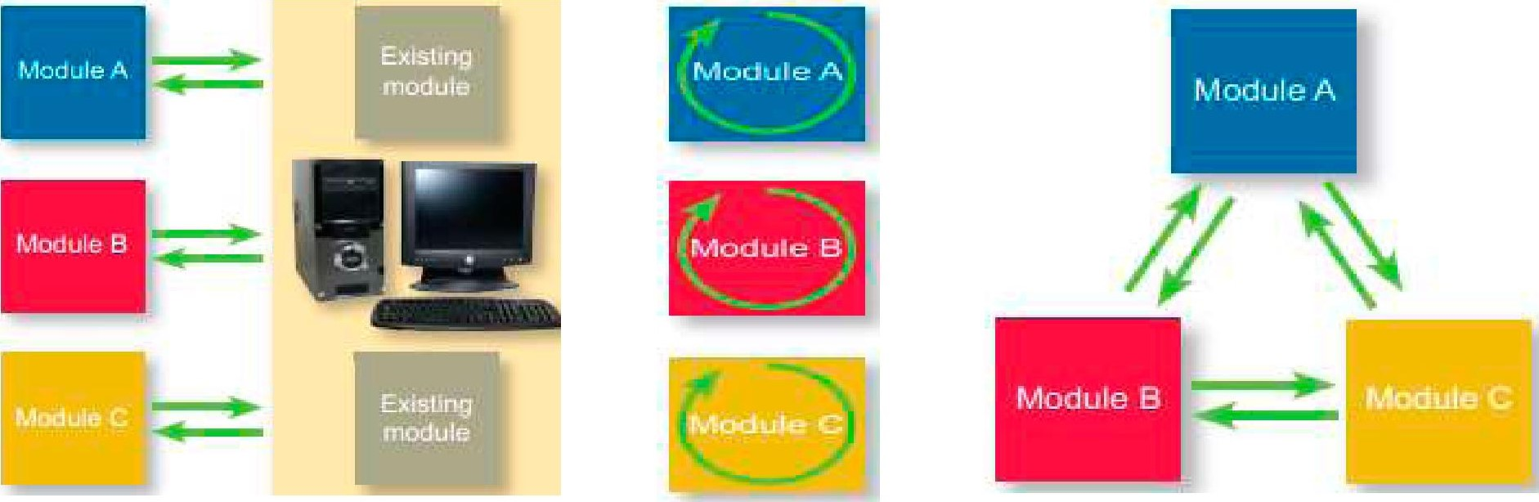

5. One more activity in the implementation phase is converting data to a new system. There are several strategies to do it. Read the abstracts (A—D) below and decide which of the following options each of them corresponds to and name their key characteristics.

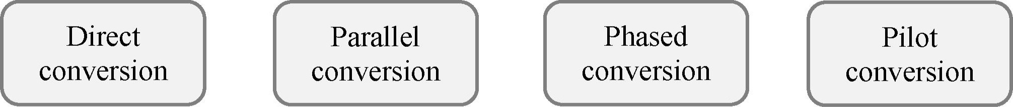

1. It avoids some of the risk of direct conversion because the old system remains in service while some or all of the new system is activated. Both the old and new systems operate in parallel until the project team can determine whether the new system is performing correctly. It often requires that all entries be made in both the new and old systems, which is costly in terms of time, computer resources, and personnel. It offers a good safety net in case a new information system fails to operate reliably or accurately
2. It works well in organisations with several branches that have independent information processing systems because the new information system is activated at one branch at a time. If the new system works correctly at one branch, it is activated at the next branch. To prepare for it, system developers must devise methods to integrate information from branches using the new system with information from branches still using the old system
3. It works well with large, modularised information systems because the new system is activated one module at a time. After the project team determines that one module is working correctly, the next module is activated, and so on, until the entire new system is operational. In it, however, each module of the new system must work with both the old and new systems, which greatly increases the complexity and cost of application development
4. It means that the old system is completely deactivated, and the new system is immediately activated. It usually takes place during non-peak hours to minimise disruption to normal business routines. It's risky, however, because if the new system doesn't work correctly, it might need to be deactivated and undergo further development or testing. In the meantime, the old system must be reactivated, and transactions that were entered into the new system must be reentered into the old one

6. Look at the diagrams and identify which type ofconversion in Task 5 they illustrate. Make a list of their advantages and disadvantages. Work in groups of three orfour people. Then share your ideas with the rest of the group.

1. 2.

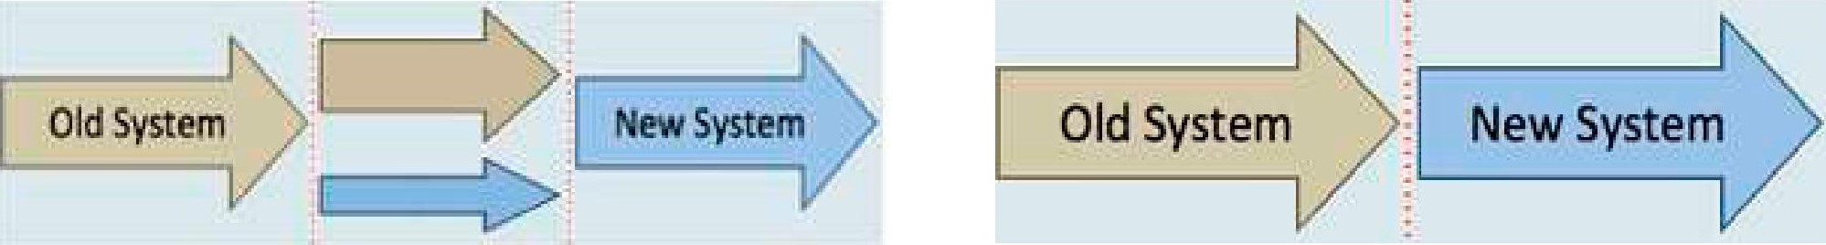

3. 4.

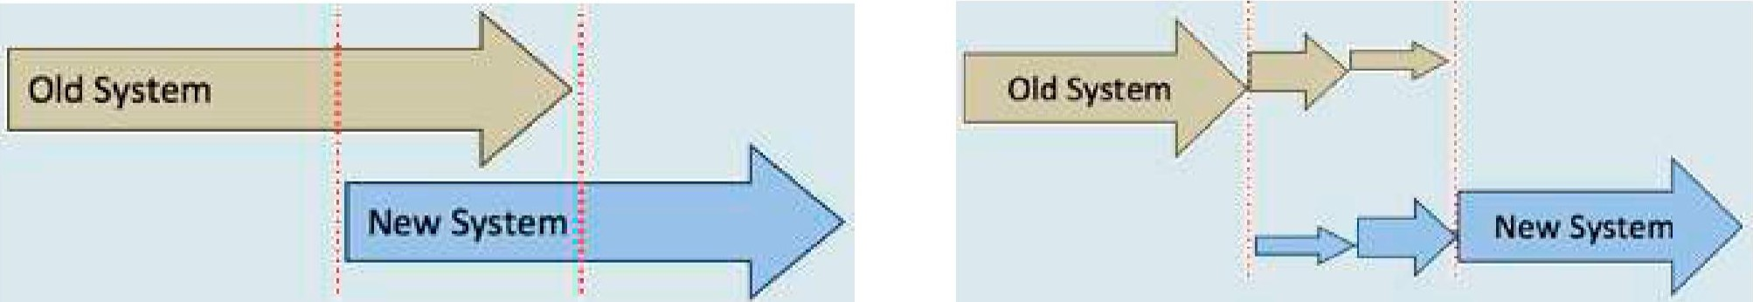

1. Group the advantages and disadvantages according to the type of conversion they refer to in Task 5.

|  |  |
| --- | --- |
| Advanta es | Disadvanta es |
| l . Risk is reduced.   1. Small minor errors can be easily seen. 2. It is less costly. 3. It is not very time consuming. 4. As the system is tested at every stage, there is very little chance of error. 5. Companies are able to fix any problems with the new system before ending the previous system. 6. This strategy is more user friendly. The IT staff are able to draw their attention to training one department at a time. 7. It allows to see whether the new system meets the organisations needs in one department/location before using it throu hout the entire or anisation | l . It is very costly as two systems are being operated simultaneously.   1. It is very difficult to detect small errors in the new system. 2. It is also very time consuming and can be stressful. 3. Too much time is involved in testing in one location, there is also increased development and labour costs. 4. It takes a lot of time to implement the whole new system to the entire organisation. 5. If the system has not been implemented properly, the new system may fail to work and this will affect the whole or anisation |

1. To sum up your knowledge about the design and implementation phases, think of five questions related to the topic and address them to your groupmates.

IV. Decision Bank

l. Watch the video "Project Management Scope Creep " [39] and mark the statements as true orfalse. Correct the false ones.

1. Scope creep is controlled changes to the scope due to the interference from stakeholders.
2. When things are moving away from what you originally thought, you should get an additional budget.
3. When people ask for additional stuff, ask them to explain the reasons.
4. Change control is the way to understand the benefits and impact of the change.
5. When people fill out a change control form, very often they understand that their changes are important.
6. Priority matrix, it is the simplest and the most powerful tool, that you do in the end of the project with your team.
7. Priority matrix is around scope and time.
8. Priority matrix is an amazing powerful tool to ensure that scope creep doesn't even happen.
9. In ordinary life changes are rare.
10. Watch the video again and name three most important tools to avoid scope creep.
11. Make a list of potential solutions how to avoid scope creep. Use the following prompts. Work with a groupmale.

v/ stakeholders and users scope v/ conflicts v/ management plan v/ requirements v/ schedule v/ changes v/ project team members

1. Study the real examples of scope creep. Work out the best ways ofpreventing such situations.
2. A significant delay in completing a project due to clients' consistent change requests, as was seen in the lawsuit between the contractor responsible for building Kitchener's main library extension and the city. The root cause of such scope creep is making too many last-minute changes on a project, causing unseen delays
3. The Chrysler Corporation had everything in check for the introduction of the Chrysler PT Cruiser, from the design, production, and promotion. However, they did not take note of dealer showroom delivery times when drafting the project requirement. This threw them off guard, with the top heads trying as much as possible to deal with the problem while responding to angry dealership owners who had their ideas. The root cause of such project scope creep is the failure to involve the client throughout the project. Chrysler did not take time to determine what the dealers wanted and had to suffer angry dealership owners who had their ideas
4. The luggage handling system in the Denver International Airport failed as a result of ignoring warnings from several parties. The set deadlines for the projects were never achieved. The keyholders were also not involved in decisions, making this one of the most expensive scopes creeps in the world. The root cause of this project scope creep was failing to prioritise features. Remember, the whole project failed because the airport ignored warnings from different parties

## V. Conclusion Worksheet

Design an information system by completing the activities below. Form a group of three or four students as the project team. Present your information system to the group.

Identify and briefly describe a type of information system that you have chosen. v/ Make a list of hardware options for your system. v/ Choose software solutions for the system. v/ Define type(s) of testing of the system.

v/ Identify type(s) of converting data that is(are) the most suitable for your system. v/ Finally, advertise your product to your groupmates.

## VI. Web Search

Explore the resources in the list to obtain additional information on the SDLC, including issues ofdata security. Report yourfindings in writing.



https://ecomputernotes.com/mis/system- https://www.britannica.com/topic/ https://doit.maryland.gov/SDLC/ development-approaches/system- information-system development-life-cycle 2008%201mplementation%20Phase

%20Multiple%20Hardware.pdf

Ml. Revision Point

l. Read the abstract "How to Avoid Feature Creep " and translate it into Belarusian or Russian. Use a dictionary ifnecessary.

# How to Avoid Feature Creep

Feature creep, more commonly known as scope creep, refers to when you add excessive features to a product that make it too complicated or difficult to use. Any additional features you introduce into your product add to the complexity of your design. In turn, this can diminish the usability of your product. Feature creep is typically the result of poor planning, insufficient product strategy, and misaligned priorities. Typically, requests for new features are added after the project has started, are out of scope, and the changes are not properly reviewed. If you're building a product for your own business, such as an app, it's important to stay focused on creating a strong minimum viable product (MVP) and ship it. You can always add features later on after you get feedback from your merchants and/or users. To help focus your project on core features, you need to: start with user and market research; identify your target audience, their needs, and their wants; know what problem you are solving, and for what user. Prioritise all features in your product according to the needs of your users. It's recommended to use the jobs-to-be-done framework to identify the key features that offer the most value to your target audience.

1. Do the quiz.

|  |  |
| --- | --- |
| l . What is the main goal of the design phase? | 1. to make system requirements report 2. to evaluate hardware and software solutions 3. to make a Project Development Plan d to create, test and convert a s stem |
| 2. What do hardware alternatives include? | 1. network technology 2. processing methodology 3. level of automation d all of the above |
| 3. What is not a software alternative? | 1. turnkey system 2. system from scratch c) cloud hosting d a lication software |
| 4. What is the main goal of the implementation phase? | 1. to create, test and convert a system 2. to make a system requirements report 3. to train users 4. to fix bugs |
| 5. Which type of testing  ensures that new modules work with the rest of the s stem? | 1. unit testing 2. acceptance testing 3. integration testing d s stem testin |
| 6. Which type of conversion involves complete deactivation of an old system? | 1. direct 2. phased 3. parallel 4. pilot |
| 7. What is scope creep? | 1. it is what happens when changes are made under developer's control 2. it is what happens when changes are made without any control 3. it is an additional function at the request of the customer d it is function chan es |

1. Choose the options from the ones given in italics to make true sentences.
   1. Direct parallel conversion is less costly.
   2. Integration unit testing is the phase in software testing in which individual software modules are combined and tested as a group.
   3. Approval in the implementation design phase is necessary to see if the information system meets the system requirements.
   4. In pilot direct conversion the old system has stopped being used and the new system is immediately being set up.
   5. In a turnkey system system from scratch you can almost immediately start using the product.
   6. Employing a system from scratch lurnkey system is significantly long.
   7. System integration testing is a type of testing that is performed on a complete integrated system to evaluate the compliance of the system with the corresponding requirements.
2. Get ready to speak on the topics below and assess your performance according to the following scale.

|  |  |  |
| --- | --- | --- |
| Comprehensive | Rather confident | Limited |

* + - Definition of the design phase; its purpose and activities.

 Hardware and software solutions.

 Definition of the implementation phase; its purpose and activities.

 Types of testing.

* + - Types of conversion.  Scope creep.

# Lesson 3: System Maintenance

|  |  |
| --- | --- |
| Aim | 0b •ectives |
| Master communication skills and competences in the maintenance phase within system development life cycle and the aspects of s stem securi | At the end of this lesson, students will be able to:   * state the goal and main activities of the maintenance phase * describe the possible modification types and quality of service • analyse threats against information systems and security measures * discuss and present findings in pairs and small groups * write a summ based on different media |

## I. Lead-in

l. Analyse the three lists of activities describing lhe design, implementation and maintenance phases. Match each of them with the appropriate phase of the SDLC. Work with a groupmate.

|  |  |  |  |  |
| --- | --- | --- | --- | --- |
|  | Purchase and | B. | Operate equipment C. v/ | Identify potential |
|  | hardware and/or |  | Make backups | solutions |
|  | software |  | Provide help to | Evaluate solutions, |
|  | Create applications |  | users | select the best ones |
|  | Test applications |  | Fix bugs | Select hardware |
|  | Fina(ise |  | Optimise for speed | and software |
|  | documentation |  | and security | Develop application |
|  | Train users |  | Revise software as | specifications |
|  | Convert data |  | necessary to meet | Obtain approval to |
|  | Convert to the new system |  | business needs | implement the new system |

2. Share your opinion on the questions with a groupmate. routine

|  |  |
| --- | --- |
| the word cloud on the right and the list of activities in | adjustmentmaintenanceassessment guidelines modifyequipment |
| Task 1 if necessary.  b) How long does it last? | replacement inspection  preventive |
| 1. Who is responsible for this phase? 2. What does QoS stand for? | quality st condition |

a) What is the main goal of the failures maintenance phase? Address regular satisfy



•

worn

## Il. Vocabulary Focus

l. The maintenance phase of the SDLC has particular features. Decide which of the statements (a—g) characterise this phase. Match the words in bold with their synonyms in the box. Work in groups of three or four people. Then watch the video "SDLC: Maintenance Phase " [42] and check ifyour ideas were right.

fixed; check; unimportant; stops; modified; satis evaluation; bu s; im lemented

1. As soon as the new system is in place, the work of the project team ceases.
2. This is the shortest and insignificant phase.
3. The maintenance phase can also be called monitoring and assessment.
4. The purpose of this phase is to verify whether the new system is satisfying the goals identified during the design phase.
5. If any errors are found, they are corrected in the maintenance phase.
6. The new system can't be altered during this phase.
7. A new system should be deployed to accommodate specific needs.
8. Complete the gaps with the missing words. Then watch the video again and check.

1) the new system is in place the work 2)  stop. The maintenance phase continues until the system is 3)  in place. During this phase the system is monitored to 4)  that it's working properly and is meeting the goals 5) during the analysis phase. If any errors or bugs are 6) they are fixed in the maintenance phase. In addition, the system may be 7)  to accommodate new needs that 8) If the new need cannot be met by the 9)  system, the cycle starts over to design a 10)  modification to the system or to 11)  a new system. It continues until a new system is in place that 12)the needs of its users.

1. While evaluating the performance ofa new information system there are three main considerations that should be taken. Distribute the questions (a-i) between the three categories.

|  |  |  |  |  |
| --- | --- | --- | --- | --- |
| Efficiency |  | Usability |  | Appropriateness |

* 1. Are all the users able to use the system easily?
  2. Does the new system operate quicker?
  3. Can all users enter and delete data safely?
  4. Is the new system suitable for the business?
  5. Does the new system reduce staff time?
  6. Does the software meet the needs of the clients and customers?
  7. Can the staff use the system with minimal training?
  8. Does the new system match the original requirements?
  9. Does the new system reduce costs?

1. In the maintenance phase, management should establish change controls that address major, routine, and emergency software modifications, and software patches. Match each type with the appropriate description (A—D) below tofind out theirfeatures.

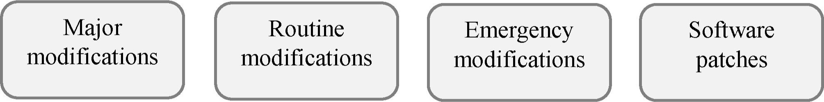

|  |  |  |
| --- | --- | --- |
| A. They are periodically needed to correct software problems or restore processing operations quickly. Although the changes must be completed quickly, they should also be implemented in a well-controlled manner |  | C. They are program modifications involving externally developed software. Their standards should include identifying, evaluating, approving, testing, installing, and documenting changes |
| B. They include significant functional changes to an existing system, converting to a new system, and introducing new systems or data. They should be implemented following a well-structured process similar to the  SDLC |  | D. They involve making changes to application or OS software to improve performance, correct problems, or enhance security. They can be simple or complex, but are not of the magnitude of major modifications, and can be deployed in the normal course of business |

1. Match the beginnings (1—6) of the statements with the appropriate endings (a—D to understand what happens in the maintenance phase.
   1. The maintenance phase involves making changes to hardware, software, and documentation
   2. It includes making changes
   3. To ensure modifications do not disrupt operations or degrade a system's performance or security, organisations should
   4. Change management (sometimes referred to as configuration management) involves
   5. Change controls should address all aspects of an organisation's technology environment
   6. Management should
   7. establish appropriate change management standards and procedures.
   8. carefully document all modifications to ensure accurate system inventories.
   9. to improve system's performance, correct problems, enhance security, or address user requirements.
   10. including software programs, hardware and software configurations, operational standards and procedures, and project management activities.
   11. to support its operational effectiveness.
   12. establishing baseline versions of products, services, and procedures and ensuring all changes are approved, documented, and disseminated.
2. The level ofperformance ofany information system Metrics — a set of numbers defines its quality of service (QoS) and can be measured with the help ofquality-of-service metrics. that give information about a To understand how [hey work, match [he QoS metrics particular process or activity on the left with the appropriate definitions.

|  |  |
| --- | --- |
| l. Throughput   1. Accuracy 2. Downtime 3. Capacity 4. User levels 5. Response time | 1. is the number of users at peak, average, and low times. 2. is the amount of time during which a system isn't available for processing. 3. is the number of errors occurring in a particular time interval for a particular function. 4. is the amount of data processed in a particular time interval. 5. is a time period between when a user initiates a request for information and when the request is fulfilled. 6. is available storage space, number of users, number of connections, or number of ackets |

1. Read the three passages (A C) and learn who is responsible for technical support in the maintenance phase. Complete the gaps with the words in the boxes.

installing; performance; operator; charged with; backups; applications; programmer; troubleshoots; maintenance; manager

* + 1. In an information system that revolves around a mainframe computer or network servers, the task of operating the mainframe or servers on a day-to-day basis is usually the responsibility of a computer 1) The computer operator performs system 2) and data recovery, monitors system traffic, and 3)operational problems. Additional responsibilities might include 4) new versions of the



operating system and software 5) but in some organisations, these responsibilities are delegated to a systems 6) whose responsibilities include installing new versions of the operating system and modifying operating system settings to maximise 7) In an information system structured as a LAN, a network 8) responsible for day-to-day operations and system 9) Some maintenance activities might also fall on the shoulders of individual users, who are often 10) the



responsibility of backing up their workstations and installing new software.

keep; in-depth; handbook; staffed; hesitate; turn to; familiar; encounter; tolerance; handle

* + 1. Even after 1)training, employees sometimes forget procedures or have difficulty when they 2) a new set of circumstances. These employees 3) the IT department for help. Many organisations establish a help desk to 4) enduser problems. The help desk is 5)  by technical support specialists who are 6) with the information system's software. Support specialists 7)records of problems and solutions. Help desk personnel have little 8)for people who ask questions that are clearly answered in the procedure 9)  or user manual. You should not 10) however, to ask about procedures or problems that are not covered in the documentation.

cost-effective; remain; retired; costl ; obsolete

* + 1. The maintenance phase is the longest SDLC phase and lasts until the system is l) Although the analysis, design, and implementation phases of the SDLC are 2) for many organisations, the maintenance phase is the most expensive because it is the longest. The maintenance phase continues until an information system is no longer 3)or until changes in the organisation make the information system 4) not unusual for an information system to 5)in operation for 20 years or more.

1. Share your opinion on the questions.
   1. What characterises the maintenance phase?
   2. What should be considered during this phase?
   3. What are the four possible types of modifications in the maintenance phase?
   4. What does QoS stand for? What does it include?
   5. Who is responsible for system maintenance?
   6. Why do maintenance activities include user support?
   7. How long does the maintenance phase last?
   8. When does the maintenance phase end?

Ill. Language Box

l. With the opening ofinformation systems to the Usets Management

Convutegs Authorization global Internet, information security has moved cn Network Protection to the forefront of concerns about global well- INFORMATION being. Make a list ofkey concepts related to the topic. Use the ideas on the right. ? CryptcxJKaphy 8 Identifiætion

1. Identify which types of threats to the stored data on the left correspond to which descriptions. Choose the three most serious ones. Justify your choice.

|  |  |
| --- | --- |
| 1. Natural disasters 2. Power outages 3. Equipment failures 4. Human errors 5. Software failures 6. Security breaches 7. Acts of war 8. Malware | 1. can occur in any hardware component of a computer system; the risk increases as a hardware component ages, but they can occur in brand-new hardware. 2. include stolen data, physical intrusions, and deliberate sabotage. 3. can be caused by bugs or flawed software design. 4. can be caused by natural disasters, overloaded power grids, planned brownouts, and rolling blackouts. 5. can cause physical damage to computer systems; cyberterrorism can also cause damage, using viruses and worms to destroy data and otherwise disrupt computer-based operations, which now include critical national infrastructures such as power grids and telecommunications systems. 6. can damage just about any computer system; you might have experienced the nuisance of rooting out a virus from your personal computer; that inconvenience pales when compared to the potential effect of a virus on a corporate information system. 7. can completely shut down a computer system, cut off service to customers, and potentially destroy the system completely. 8. are mistakes made by computer operators. Common ones within an information system include entering inaccurate data and failin to follow re uired rocedures |

1. Distribute the threats in Task 2 between the two groups. Then choose the most and least serious ones in each groupfor Belarus. Justify yourpoint ofview. Work with a groupmate.

|  |  |  |
| --- | --- | --- |
| Naturally happened |  | Human inflicted |

1. No computer system can be completely risk-free, but several proactive measures can protect information systems from threats. These measures can be grouped into the four categories: deterrents, preventive countermeasures, corrective procedures, and detection activities. Distribute the measures (a i) between the categories. Work with a groupmate.

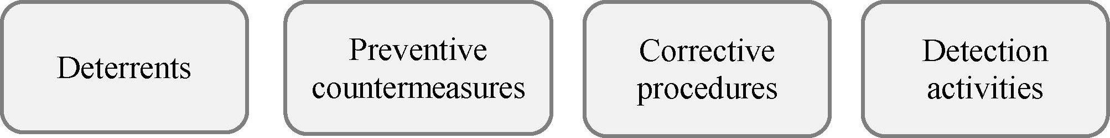

a)

d)

g)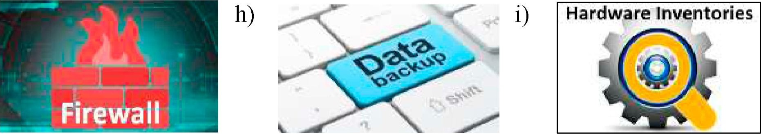

1. To ensure secure and efficient operation of information systems, an organisation institutes a set ofprocedures and technological measures called controls. To learn more about them match the beginnings of the statements (1 7) with the appropriate endings (a—g).
   1. Information systems are safeguarded
   2. General controls apply
   3. The most important general controls are .
   4. General controls include administrative measures .
   5. Fault-tolerant computer systems installed in critical environments are
   6. Backup systems, often in remote locations, may be 7. Application controls are
   7. that restrict employees' access to only those processes directly relevant to their duties.
   8. the measures that control access to computer systems and the information stored.
   9. designed to control and isolate problems so that the system can continue to function.
   10. to information system activities throughout an organisation.
   11. through a combination of general and application controls.
   12. specific to a given application and include such measures as validating input data, logging the accesses to the system, regularly archiving copies of various databases, and ensuring that information is disseminated only to authorised users.
   13. activated in the case of failure of the primary information system.
2. Read the abstract "Information Systems Security" and underline the core characteristics that give you a view of this concept. Compare your ideas with the groupmates.

# Information Systems Security

Information systems security is responsible for the integrity and safety of system resources and activities. Most organisations in developed countries are dependent on the secure operation of their information systems. Multiple infrastructural grids — including power, water supply, and health care — rely on it. Information systems are at the heart of intensive care units and air traffic control systems. Financial institutions could not survive a total failure of their information systems for longer than a day or two. Electronic funds transfer systems (EFTS) handle immense amounts of money that exist only as electronic signals sent over the networks or as spots on storage disks.

Information systems are vulnerable to a number of threats and require strict controls, such as continuing countermeasures and regular audits to ensure that the system remains secure.

Although instances of computer crime and abuse receive extensive media attention, human error is estimated to cause greater losses in information systems operation. Disasters such as earthquakes, floods, and fires are the particular concern of disaster recovery planning, which is a part of a corporate business continuity plan. A contingency scheme is also necessary to cover the failure of servers, telecommunications networks, or software.

1. Look at the places in the pictures. What do they all have in common? Analyse the vulnerabilities of one of them and offer protective measures that should be taken to secure data. Work with a groupmate. Then report your ideas to the group.



1. Natural disasters and flaws in critical software that controls air traffic or nuclear powerplants can be deadly. Other bugs and human errors may cause security leaks that allow unauthorised access to corporate servers. Consider all aspects of information system maintenance and data security and make a short presentation to the group.

IV. Decision Bank

l. In the age ofdigitisation think ofthe advantages ofelectronic government. Consider the objectives in the box and list the activities that electronic government can provide in each case. Work in groups of three orfour people.

Objectives of Electronic Govemment

 Better delivery of public services to people

 Enhancing business and industry collaborations  Citizen empowerment through access to information

 More effective governance

1. Choose the facts from the list that are essential for electronic government. Justify your point ofview.

I. Electronic government (or e-government) encompasses all government roles and activities, shaped by information and communications technologies.

* 1. E-government has been employed to mean everything from online government services to exchange of information and services electronically with citizens, businesses, and other arms of government.
  2. Because of its advantages, electronic government has the potential to attract netsavvy young citizens who have traditionally tried to avoid the paper-based system.
  3. The e-government's ultimate objective is to offer enhanced portfolio of public services in an efficient and cost-effective way to citizens.
  4. It also simplifies the process of getting services for elderly and homebound citizens.
  5. E-government can satisfy transparency expectations of their citizens.
  6. Security issues and data protection are still the main concerns of official digital services.

1. Read the article "Electronic Government and Digital Public Services " and define its main message. Complete the following ideas.

l. Electronic government or e-government is .

* 1. This definition demonstrates how e-government
  2. The appropriate application of e-government allows for
  3. E-government could be classified as two types:
  4. The primary benefit of e-government would be
  5. E-government and its capacity could be available to
  6. The primary disadvantages of e-government are .

# Electronic Government and Digital Public Services

Electronic government (or e-government) is the application of Information and Communication Technologies (ICTs) to government functions and procedures with the purpose of increasing efficiency, transparency and citizen participation. This definition demonstrates how e-government uses ICTs as a support tool in the development of good governance. The appropriate application ofe-government allows for higher levels of effectiveness and efficiency in governmental tasks, improvement of processes and procedures, increases the quality of public services, also improves the use of information in the decision-making processes and allows for better communication among different governmental offices.

## E-Governance Types

Some people believe that e-government is merely a website that could deliver public services through the Internet. This is however an oversimplification of the capacity of e-government. E-government could be classified as two types:

* E-services: digital provision of services, programs and information by governments.
* E-collaboration: Internet or digital communications which could boost participatory public activities like voting or even paying tax.

## E-government's advantages

The e-government's ultimate objective is to offer enhanced portfolio of public services in an efficient and cost-effective way to citizens. The e-government also could provide more transparency for the government because it enables the public to be informed about what government is working on and the policies which are enforced.

The primary benefit would be replacing and optimising the paper-based system while implementing electronic government. That could save lots of time, money and also environment in return due to reducing paper consumption.

The implementation ofe-government could also promote better communications between government and business sectors. Hence the benefit of e-government could be creating open and transparent market and a stronger economy. Nowadays, companies and people can get information quicker and at any moment of the day in comparison to the past. E-government and its capacity could be available to all people regardless of their place or social level.

In summary, more efTiciency, enhanced services to better serve citizens, better accessibility of public services, more transparency and accountability of government are the expected advantages of e-government.

The e-government disadvantages

E-government is not all about advantages, but it also has some disadvantages, too. The primary disadvantages of e-government are the absence of public Internet access for all citizens, protection of the published information on the web by the governmental agencies, and also capabilities of government and its agencies which can potentially affect public activities.

4. Some experts are still very critical about electronic government. Can you agree with their statements (a c)? Bring your arguments for e-government. Work in groups of three orfour people.

1. Higher surveillance and monitoring: once government implements e-government, people will be compelled to communicate with it on a wider scale electronically. As the government receives more and more information about its citizens, this could possibly lead to a lack of privacy for civilians.
2. Being too costly: implementing, maintaining and optimising e-government is not cheap and requires spending lots of money.
3. Inaccessibility for all: e-government couldn't be accessible by all including those who are living in distant regions or have low rates of literacy and income on the poverty line.

## V. Conclusion Worksheet

In Belarus the system "Electronic government" was created in 2003 within the framework ofthe state program "Electronic Belarus ". Today information technologies are actively used in all spheres ofthe public life, and they give a powerful incentive to economic and social development ofthe country.

(Source: https: mfa.gov.by en press news mfa dcf3c0efcf43a87a.html)

Address the national centre of electronic services nces.by and list the options that electronic government offers today. Consider the challenges of e-services in Belarus including the ones listed below and get ready to report yourfindings to the rest ofthe group:

network security v/ identification and access control v/ usability

## VI. Web Search

Explore the resources in the list to obtain additional information on the SDLC, including issues ofdata security. Report yourfindings in writing.



https://ecomputernotes.com/mis/ https://www.aaas.org/ https://www.cisco.com/c/en/us/ implementation-and-evaluation epi-center/internet-online-voting solutions/data-center-virtualization/ what-is-a-data-center.html

Ml. Revision Point

l. Do the crossword and get the key terms ofthis lesson.

1. Sth that you must do, or sth you need.
2. The fact of sth being easy to use, or the degree to which it is easy to use.
3. A change to sth, usually to improve it.
4. 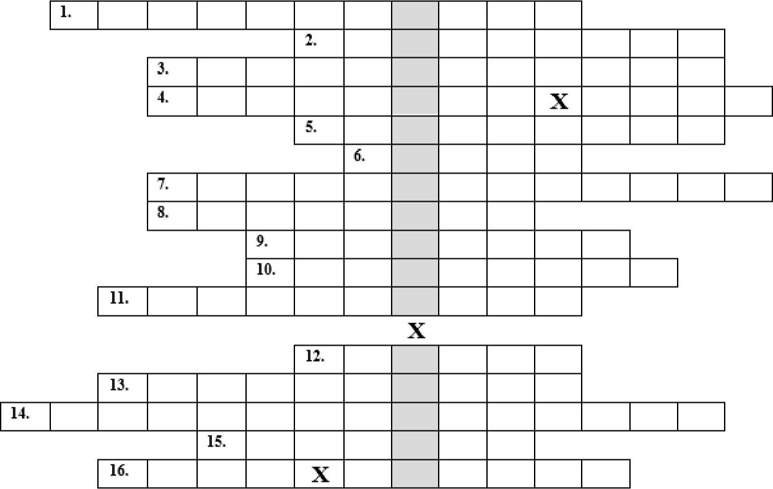Time period between when a user initiates a request for information and when the request is fulfilled.
5. To start a company or organisation that will continue for a long time.
6. To stop, halt, terminate sth. 7. Small or not noticeable, and therefore not considered important.
7. Number of errors occurring in a particular time interval for a particular function.
8. Amount of time a system is not available for processing.
9. A set of actions that is the official or accepted way of doing sth.
10. The quality of working well in an organised way, without wasting time or energy.
11. To use sth or sb, especially in an effective way; to launch.
12. Amount of data processed in a particular time interval.
13. The quality of being suitable or right for a particular situation or occasion.
14. To please sb by giving them what they want or need; meet the needs.
15. Number of users at peak, average, and low times.
16. Complete the gaps with the appropriate words.

The most common threats to corporate information systems include natural disasters, power 1) equipment failure, human errors, software failures, 2) breaches, acts of war, and malware. These threats can be handled in several ways. 3) reduce the likelihood of a deliberate attack. 4) countermeasures shield

vulnerabilities to render an attack unsuccessful. 5)procedures reduce the effect



of an attack. 6)activities recognise attacks and trigger a corrective response. To



protect hardware, software, and data, corporate systems are often housed in a protective facility called a data centre. Most companies have a disaster 7)plan that



describes how to secure data against disaster, reconstruct lost data, and restore normal operations after a disaster.

1. Render the article "What Is a Data Centre? " published on the PaloAlto Networks orally. Record your speech and send it to your groupmatefor assessment according to the checklist below. Your overall mark will be provided at the end of the table.

What Is a Data Centre?

Written by Tim Edvards

Mar 16, 2023

A data centre is a facility that centralises an organisation's shared IT operations and equipment for the purposes of storing, processing, and disseminating data and applications. Because they house an organisation's most critical and proprietary assets, data centres are vital to the continuity of daily operations. Consequently, the security and reliability of data centres and their information are among any organisation' s top priorities.

In the past, data centres were highly controlled physical infrastructures, but the public cloud has since changed that model. Except where regulatory restrictions require an on-premises data centre without Internet connections, most modern data centre infrastructures have evolved from on-premises physical servers to vinualised infrastructure that supports applications and workloads across multi-cloud environments.

Data centres are an integral part of the enterprise, designed to support business applications and provide services such as: data storage, management, backup and recovery; productivity applications, such as email; high-volume e-commerce transactions; powering online gaming communities; big data, machine learning and artificial intelligence.

Today, there are reportedly more than 7 million data centres worldwide. Practically every business and government entity builds and maintains its own data centre or has access to someone else's, if not both models. Many options are available today, such as renting servers at a colocation facility, using data centre services managed by a third party, or using public cloud-based services from hosts like Amazon, Microsoft, Sony and Google.

Data centre architectures and requirements can differ significantly. For example, a data centre built for a cloud service provider like Amazon satisfies facility, infrastructure and security requirements that significantly differ from a completely private data centre, such as one built for a government facility that is dedicated to securing classified data.

Regardless of classification, an effective data centre operation is achieved through a balanced investment in the facility and the equipment it houses. In addition, since data centres often house an organisation's business-critical data and applications, it's essential that both facility and equipment are secured against intruders and cyberattacks.

The primaty elements of a data centre break down as follows: facility — the usable space available for IT equipment; design to optimise space and environmental control to keep equipment within specific temperature/humidity ranges are both emphasised; core components equipment and software for IT operations and storage of data and applications including servers, network infrastructure, such as switches and routers, and various information security elements, such as fi rewalls support infrastructure equipment contributing to securely sustaining the highest availability possible including Uninterruptible Power Sources (UPS), environmental control, physical security systems, operations staff

Data centres have evolved significantly in recent years. As enterprise IT needs continue to move toward on-demand services, data centre infrastructure has shifted from on-premises servers to virtualised infrastructure that supports workloads across pools of physical infrastructure and multi-cloud environments.

|  |  |  |  |
| --- | --- | --- | --- |
| Summary checklist | Yes | Undecided | No |
| l. The ori in of the ublication was mentioned |  |  |  |
| 2. The date of the column was rovided |  |  |  |
| 3. The s le of the scri t was defined and •ustified |  |  |  |
| 4. The enre of the ost was indicated and •ustified |  |  |  |
| 5. The author of the article was called |  |  |  |
| 6. The title of the ost was iven |  |  |  |
| 7. The main idea of the article was identified |  |  |  |
| 8. The im ortant oints were included |  |  |  |
| 9. The unnecess details were left out |  |  |  |
| 10. The ersonal o inion/im ression of the article was iven |  |  |  |
| l l. The ersonal view on the to ic/ roblem was rovided |  |  |  |
| 12. The summa included own vocabula not citations |  |  |  |
| 13. The summa was full of varied grammar structures |  |  |  |
| The overall mark excellent/ ood/satisfacto [below avera e/bad |  | | |

4. Get ready to speak on the topics below and assess your performance according to the following scale.

|  |  |  |
| --- | --- | --- |
| Comprehensive | Rather confident | Limited |

* Goal, key activities, considerations of the maintenance phase.
* Types of modification during the maintenance phase.
* Quality of service and the metrics being used to measure it.
* Potential threats to information systems.
* Measures to protect data and information systems.  Advantages of electronic government.

Wordlist Topic: Information Systems

|  |  |
| --- | --- |
| Acceptance n  Accommodate v  Accuracy n  Adjustment n  Alter v  Analysis n  Appropriateness n  Assessment n  Assurance n  Bitcoin n  Blockchain n  Cease n, v  Chart n, v  Coding n  Compete v  Cost-effective adj  Creep n, v  Customisation n  Debugging n  Deploy v  Derive v  Design n, v  Determine v  Deterrent n, adj  Devise v  Downtime n  Eliminate v  Encounter n, v  Engage v  Ensure v  Evaluation n  Expansion n  Extensively adv  Handbook n  Implementation n  In-house adj  Insignificant adj  Integration n  Interrelated adj  Inventory n  Kit n  Maintenance n  Manual n, adj  Methodology n  Metrics n, p/  Objective n, adj  Ongoing adj | Outsource v  Requirement n  Scope n, v  Shell n, v  Sign (off) v  Supervise v  Throughput n  Tool n  Turnkey n  Unit n  Usability n  Verify v  Workflow n  Collocations:  Application development tool  Application specifications  Business level testing Construct a prototype  Corrective procedure  Detection activity  Development methodology  Direct/parallel/phased/pilot conversion  Emergency/maj or/routine modifications  Evaluation checklist  Feature/scope creep  Fix a bug  Meet the goal/need/requirement  Power outage  Preventive countermeasure  Proj ect costs  Proj ect development plan  Proj ect justification  Proj ect schedule  Proj ect team  Response time  Revised information system  Security breach  Software patches  Success factor  System from scratch  System requirements report  Tax compliance  Trial version  User levels |

List of Abbreviations

|  |
| --- |
| ADSL — Asymmetric Digital Subscriber Line  Al — Artificial Intelligence  ALU — Arithmetic Logic Unit  API — Application Programming Interface  AR — Augmented Reality  ATM — Automated teller machine (Cash-point)  BIOS — Basic Input Output System  BSoD — Black screen of death  CPU — Central Processing Unit  CU - Control Unit  DDoS - Distributed denial-of-service  DIMM Dual in-line memory modules  DL — Deep learning  DNS — Domain Name Server DOS — Denial of service dp — dot pitch  DSL — Digital subscriber line  DSS — Decision support system  FTP - File Transfer Protocol  GSM — Global System for Mobile Communication (Groupe Spécial Mobile)  GUI — Graphical User Interface  HDD - Hard Disk Drive  HTML — Hypertext Markup Language  HTTP - Hypertext Transfer Protocol  ICT — Information and Communications Technology/Technologies  ID — Identity document  InfoSec — Information security  10T - Internet of Things  IRC — Internet Relay Chat  IS — Information System  ISP — Internet Service Provider  LAN — Local Area Network  MAN — Metropolitan Area Network  MIS — Management information system  ML — Machine learning  OOP — Object-oriented programming  PAN — Personal Area Network  PC — Personal computer  PDA — Personal digital assistant  PIN — Personal identification number  POP - Post Office Protocol P2P - Peer-to-peer  P2P - Point-to-point  QoS — Quality of service  RAM — Random Access Memory |
| ROM - Read only Memory  RSS — Really Simple Syndication  SDLC — System development life cycle  SDSL — Symmetric Digital Subscriber Line  SMTP - Simple Mail Transfer Protocol  SSD — Solid State Drive  STOP — Security Tracking of Office Property  SU — System Unit  TCP/IP — Transmission Control Protocol/lnternet Protocol  TelNet — Telecommunication Network  TPS — Transaction processing systems  UDP — User Datagram Protocol  UID — Unique identifier  URL — Uniform Resource Locator  USB — Universal Serial Bus  VolP — Voice over Internet Protocol  VR — Virtual Reality  WAN — Wide Area Network  WAP — Wireless access point  Wi-Fi - Wireless Fidelity  WWW World Wide Web  XML - Extensible Marku Lan ua e |

4 1